

Programação, Automação e Robótica

Partes Robot Arm

(Download .STL)

# Mão direita

<https://inmoov.fr/inmoov-stl-parts-viewer/?bodyparts=Right-Hand>

[Auriculaire-3](https://inmoov.fr/wp-content/uploads/stl/Right-Hand/Auriculaire3.stl)

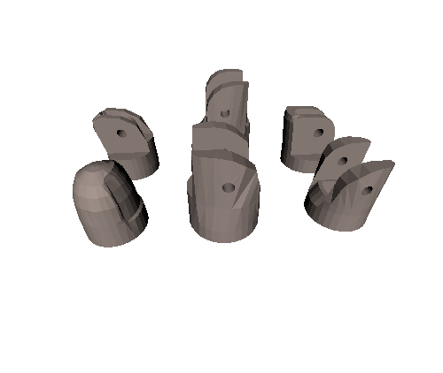

[Bolt-entretoise7](https://inmoov.fr/wp-content/uploads/stl/Right-Hand/Bolt_entretoise7.stl)

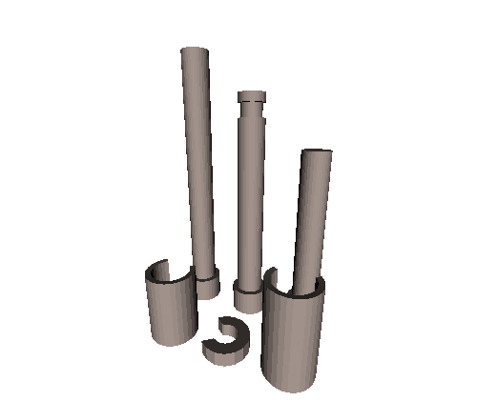

[Index3](https://inmoov.fr/wp-content/uploads/stl/Right-Hand/Index3.stl)

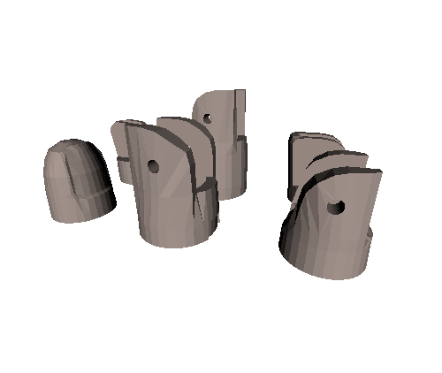

[Majeure3](https://inmoov.fr/wp-content/uploads/stl/Right-Hand/Majeure3.stl)

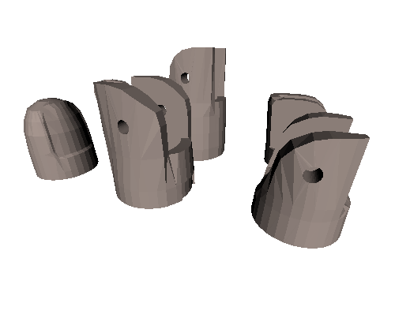

[WristlargeV4](https://inmoov.fr/wp-content/uploads/stl/Right-Hand/WristlargeV4.stl)

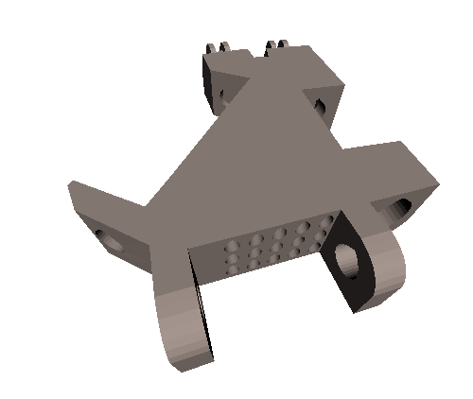

[WristsmallV4](https://inmoov.fr/wp-content/uploads/stl/Right-Hand/WristsmallV4.stl)

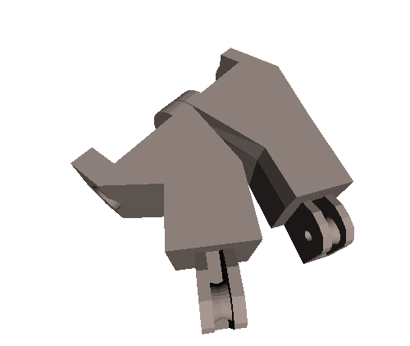

[Arduinosupport](https://inmoov.fr/wp-content/uploads/stl/Right-Hand/ardiuinosupport.stl)

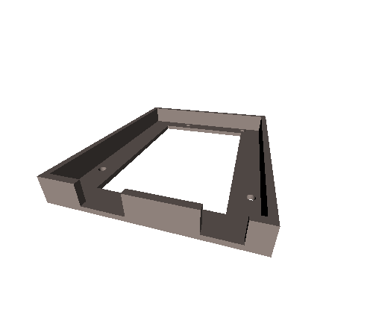

[CoverFinger](https://inmoov.fr/wp-content/uploads/stl/Right-Hand/coverfinger1.stl)

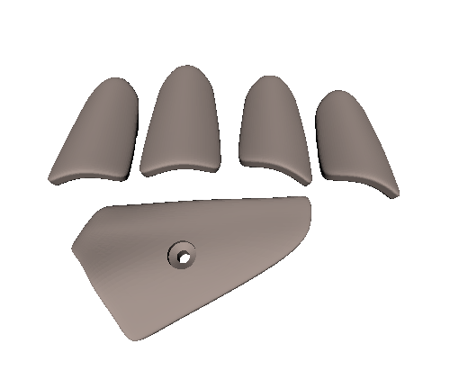

[RingFinger3](https://inmoov.fr/wp-content/uploads/stl/Right-Hand/ringfinger3.stl)

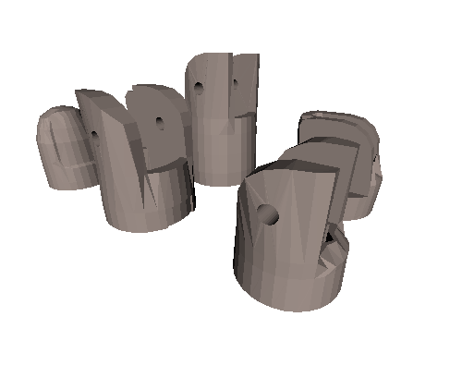

[Robcap3v2](https://inmoov.fr/wp-content/uploads/stl/Right-Hand/robcap3V2.stl)

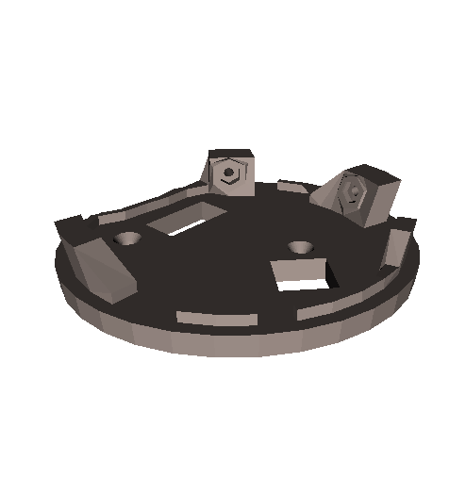

[Robpart2V4](https://inmoov.fr/wp-content/uploads/stl/Right-Hand/robpart2V4.stl)

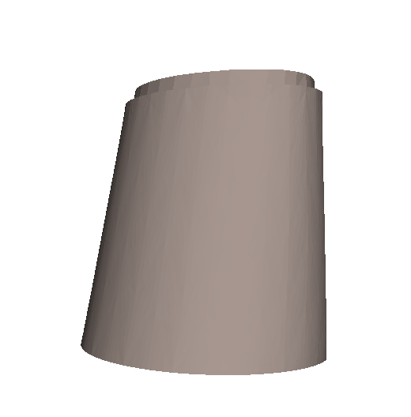

[Robpart3V4](https://inmoov.fr/wp-content/uploads/stl/Right-Hand/robpart3V4.stl)

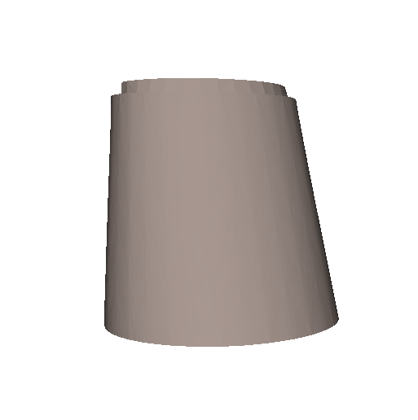

[Robpart4V4](https://inmoov.fr/wp-content/uploads/stl/Right-Hand/robpart4V4.stl)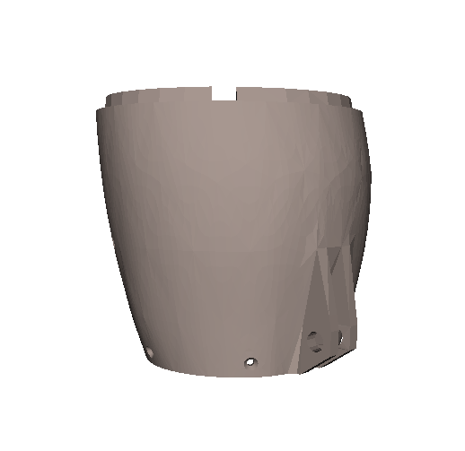

[Robpart5V4](https://inmoov.fr/wp-content/uploads/stl/Right-Hand/robpart5V4.stl)

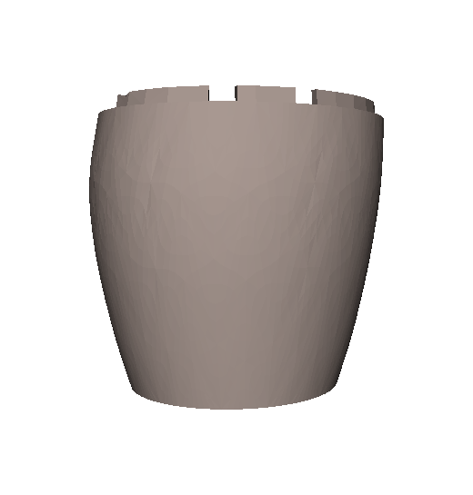

[Thumb5](https://inmoov.fr/wp-content/uploads/stl/Right-Hand/thumb5.stl)

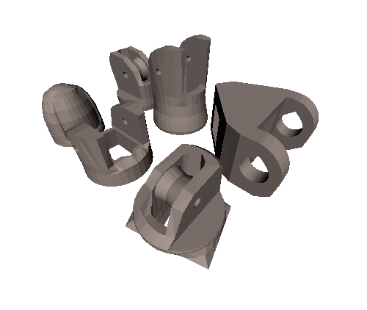

[Topsurface6](https://inmoov.fr/wp-content/uploads/stl/Right-Hand/topsurface6.stl)

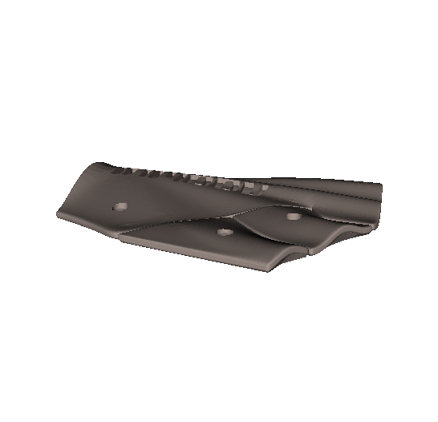

[TopsurfaceUP6](https://inmoov.fr/wp-content/uploads/stl/Right-Hand/topsurfaceUP6.stl)

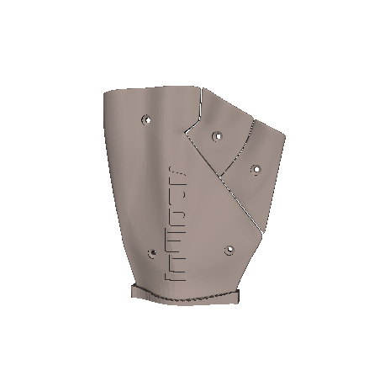

# Pulso giratório

[https://inmoov.fr/inmoov-stl-parts-viewer/?bodyparts=Rotation-Wrist](https://inmoov.fr/inmoov-stl-parts-viewer/?bodyparts=Rotation-Wrist&doing_wp_cron=1725388687.5073111057281494140625)

[CableHolderWristV5](https://inmoov.fr/wp-content/uploads/stl/Rotation-Wrist/CableHolderWristV5.stl)

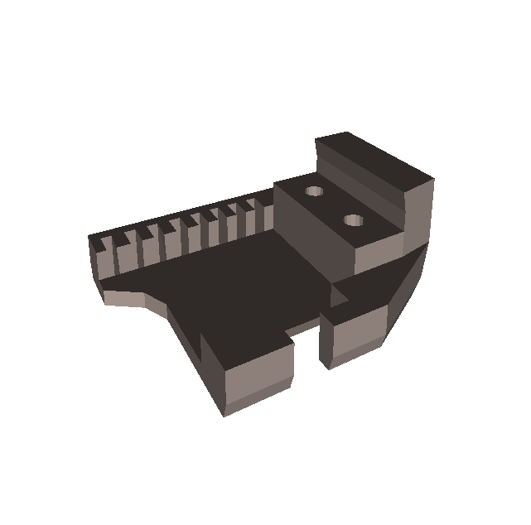

[LefCableHolderWristV5](https://inmoov.fr/wp-content/uploads/stl/Rotation-Wrist/LeftCableHolderWristV5.stl)

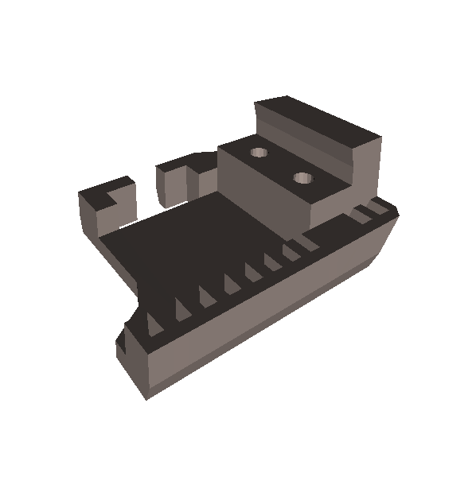

[LeftRotaWrist2V3](https://inmoov.fr/wp-content/uploads/stl/Rotation-Wrist/LeftRotaWrist2V3.stl)

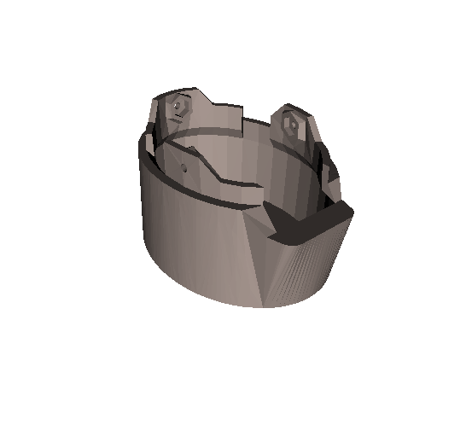

[LeftRotawrist1V4](https://inmoov.fr/wp-content/uploads/stl/Rotation-Wrist/LeftRotawrist1V4.stl)

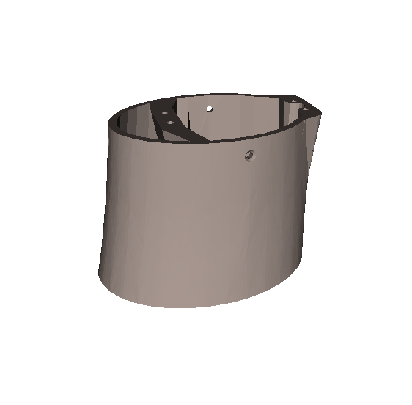

[RotaWrist1V4](https://inmoov.fr/wp-content/uploads/stl/Rotation-Wrist/RotaWrist1V4.stl)

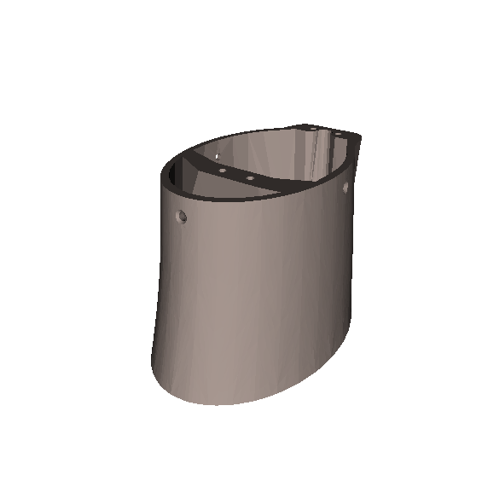

[RotaWrist2V3](https://inmoov.fr/wp-content/uploads/stl/Rotation-Wrist/RotaWrist2V3.stl)

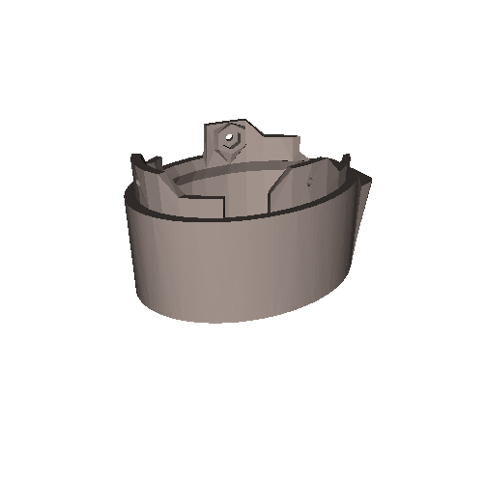

[RotaWrist3V3](https://inmoov.fr/wp-content/uploads/stl/Rotation-Wrist/RotaWrist3V3.stl)

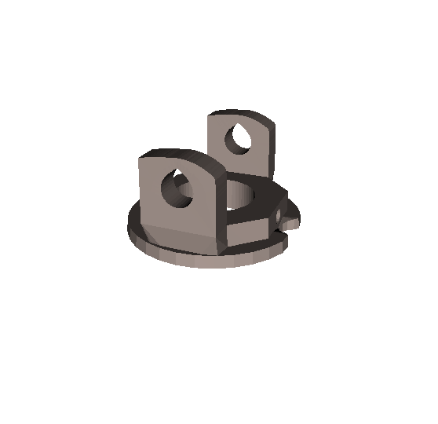

[WristGearV5](https://inmoov.fr/wp-content/uploads/stl/Rotation-Wrist/WristGearsV5.stl)

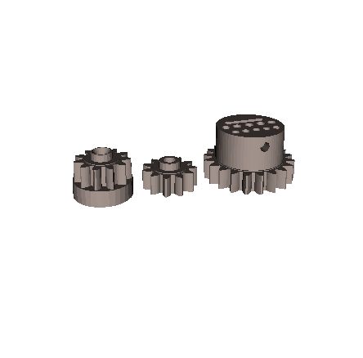

# Antebraço

<https://inmoov.fr/inmoov-stl-parts-viewer/?bodyparts=Forearm-and-Servo-Bed>

[LeftRobCableBackV3](https://inmoov.fr/wp-content/uploads/stl/Forearm-and-Servo-Bed/LeftRobCableBackV3.stl)

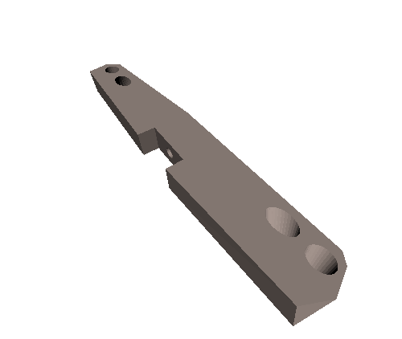

[LeftRobCableFrontV3](https://inmoov.fr/wp-content/uploads/stl/Forearm-and-Servo-Bed/LeftRobCableFrontV3.stl)

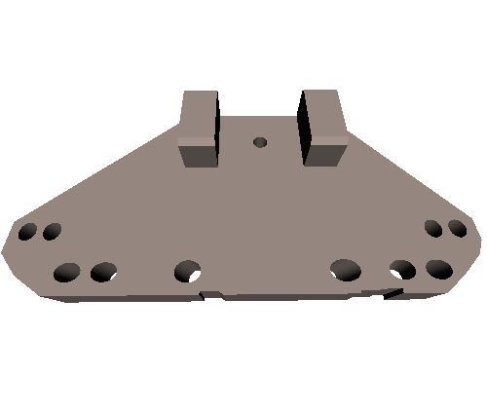

[LeftRobServoBedV6](https://inmoov.fr/wp-content/uploads/stl/Forearm-and-Servo-Bed/LeftRobServoBedV6.stl)

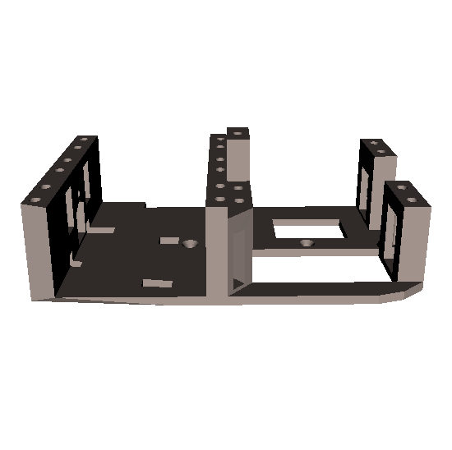

[LeftTensionerV1](https://inmoov.fr/wp-content/uploads/stl/Forearm-and-Servo-Bed/LeftTensionerV1.stl)

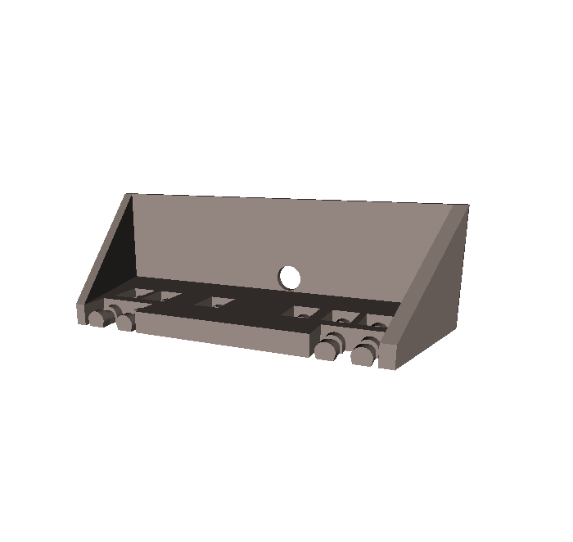

[RobCableBackV3](https://inmoov.fr/wp-content/uploads/stl/Forearm-and-Servo-Bed/RobCableBackV3.stl)

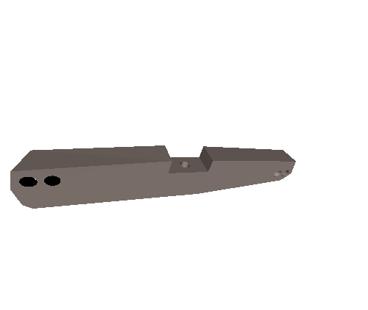

[RobCableFrontV3](https://inmoov.fr/wp-content/uploads/stl/Forearm-and-Servo-Bed/RobCableFrontV3.stl)

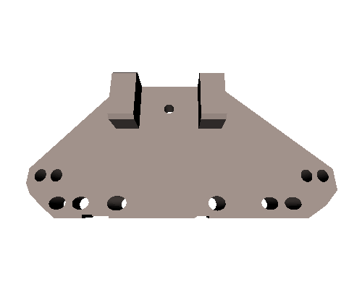

[RobRingV3](https://inmoov.fr/wp-content/uploads/stl/Forearm-and-Servo-Bed/RobRingV3.stl)

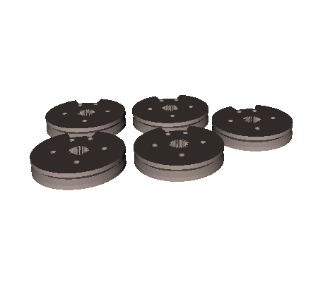

[RobServoBedV6](https://inmoov.fr/wp-content/uploads/stl/Forearm-and-Servo-Bed/RobServoBedV6.stl)

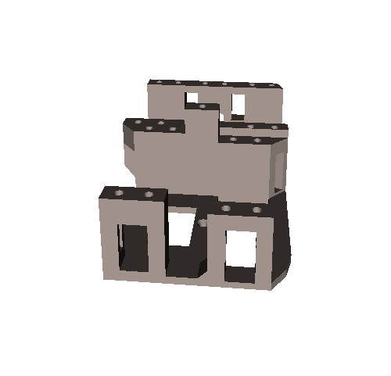

[TensionerRightV1](https://inmoov.fr/wp-content/uploads/stl/Forearm-and-Servo-Bed/TensionerRightV1.stl)

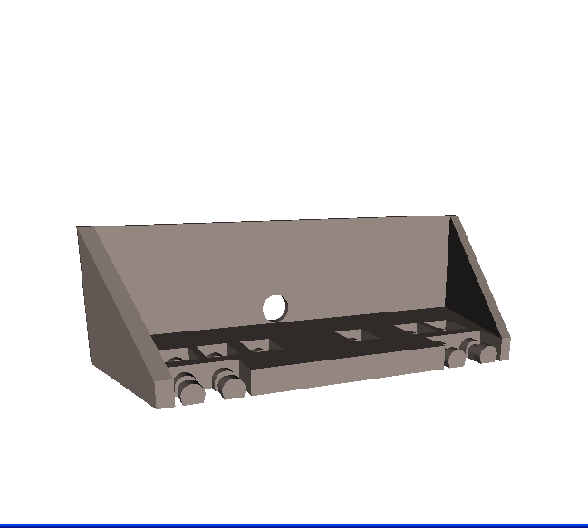

[servo-pulleyX5](https://inmoov.fr/wp-content/uploads/stl/Forearm-and-Servo-Bed/servo-pulleyX5.stl)

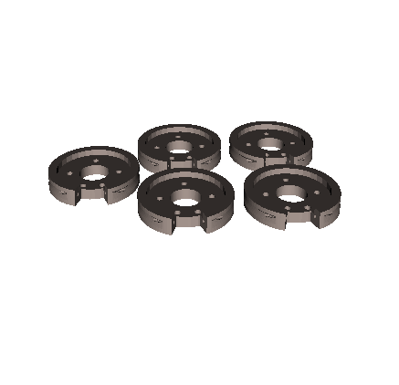

[Molde para dedos de silicone](https://inmoov.fr/wp-content/uploads/stl/Other-useful-parts/FingerTipMoldV3.stl)

